Agnostic Packer Hunting and Adversarial Feature Extraction in Static Malware Analysis using XGBoost

Dipper Pines, B0..., James McFadyen, B01666734

Abstract—Static malware analysis provides a crucial, high-speed first line of defense in enterprise cybersecurity, but it is highly vulnerable to adversarial obfuscation. Modern malware authors frequently utilize packers and string manipulation to destroy, compress, or spoof standard Portable Executable (PE) headers, rendering them invisible to traditional metadata parsers. This paper presents a highly resilient, pure-static machine learning pipeline designed to neutralize adversarial evasion without relying on computationally expensive dynamic analysis or raw byte-sequence processing. Utilizing a massive dataset of 280,000 benign and malicious files from the EMBER corpus, we engineered an "Agnostic Packer Hunter" that dynamically parses nested PE section arrays to extract maximum section entropy and virtual-to-physical size mismatches, effectively unmasking encrypted payloads. To counter parser-crashing attacks, we implemented strict regular expression sanitization on imported DLL strings, followed by Term Frequency-Inverse Document Frequency (TF-IDF) matrix weighting to mathematically penalize common system imports and highlight rare, suspicious API calls. The processed features were fed into a hyper-tuned XGBoost classifier. To address the inherent class imbalance of real-world threat environments, the model utilized dynamic class weighting optimized specifically to maximize the Cohen’s Kappa statistic. Furthermore, we eliminated training-serving skew by permanently bonding the Z-score and TF-IDF scaling dictionaries to the exported C++ inference engine. The resulting architecture successfully processed the high-dimensional data in a memory-safe, multi-core PSOCK cluster, bypassing standard out-of-memory limitations. The final model achieved an 86.5% accuracy and a highly competitive Kappa score of 0.73 on a blind test set, demonstrating decisive predictive confidence (>90%) on heavily obfuscated malware. These results demonstrate that combining structural anomaly extraction with strict mathematical feature weighting allows tree-based ensemble models to effectively serve as robust "Phase 1" filters.

Index Terms— Feature Extraction, Malware Classification, Obfuscation, XGBoost, Adverserial Evasion

I. INTRODUCTION
As the volume and sophistication of malicious software continue to escalate, enterprise cybersecurity systems face a critical bottleneck: the rapid triage of unknown executables. While dynamic sandbox analysis provides deep behavioral insights, it is too computationally expensive and time-consuming to process millions of daily threats [10]. Consequently, static malware analysis, the process of examining a file’s structural metadata without executing it, serves as an essential "Phase 1" filter. An effective static filter frees up Security Operations Center analysts and computational resources to focus exclusively on genuine, novel threats.
However, static analysis is highly vulnerable to adversarial evasion [9]. Malware authors routinely employ obfuscation techniques, such as software packers and string manipulation, to compress or hide their true payloads, rendering traditional metadata parsers blind [3], [8]. Furthermore, adversaries frequently inject illegal control characters into Portable Executable (PE) headers to intentionally crash defensive tools [6].
This paper addresses the challenge of building a high-speed, crash-proof static analysis pipeline capable of neutralizing these evasion tactics. The primary motivation for solving this problem is the critical need to develop defensive architectures that do not blindly trust spoofable file headers, but instead actively hunt for the mathematical footprints left behind by obfuscation.
Fundamentally, this is a binary classification problem: predicting whether an unseen executable is benign or malicious based on its structural characteristics. To solve this, tree-based ensemble methods, specifically Extreme Gradient Boosting (XGBoost) [2], are the most appropriate approach due to their stability and efficiency with sparse, high-dimensional tabular data. Instead of relying solely on raw metadata, the proposed methodology incorporates "Agnostic Packer Hunting" to extract structural anomalies, such as extreme section entropy and virtual-to-physical size mismatches. By combining this extraction with Term Frequency-Inverse Document Frequency (TF-IDF) matrix weighting [4] on aggressively sanitized import arrays, this report demonstrates a resilient classification system mathematically optimized to catch hidden payloads.

II. DATASET AND EXPLORATORY DATA ANALYSIS
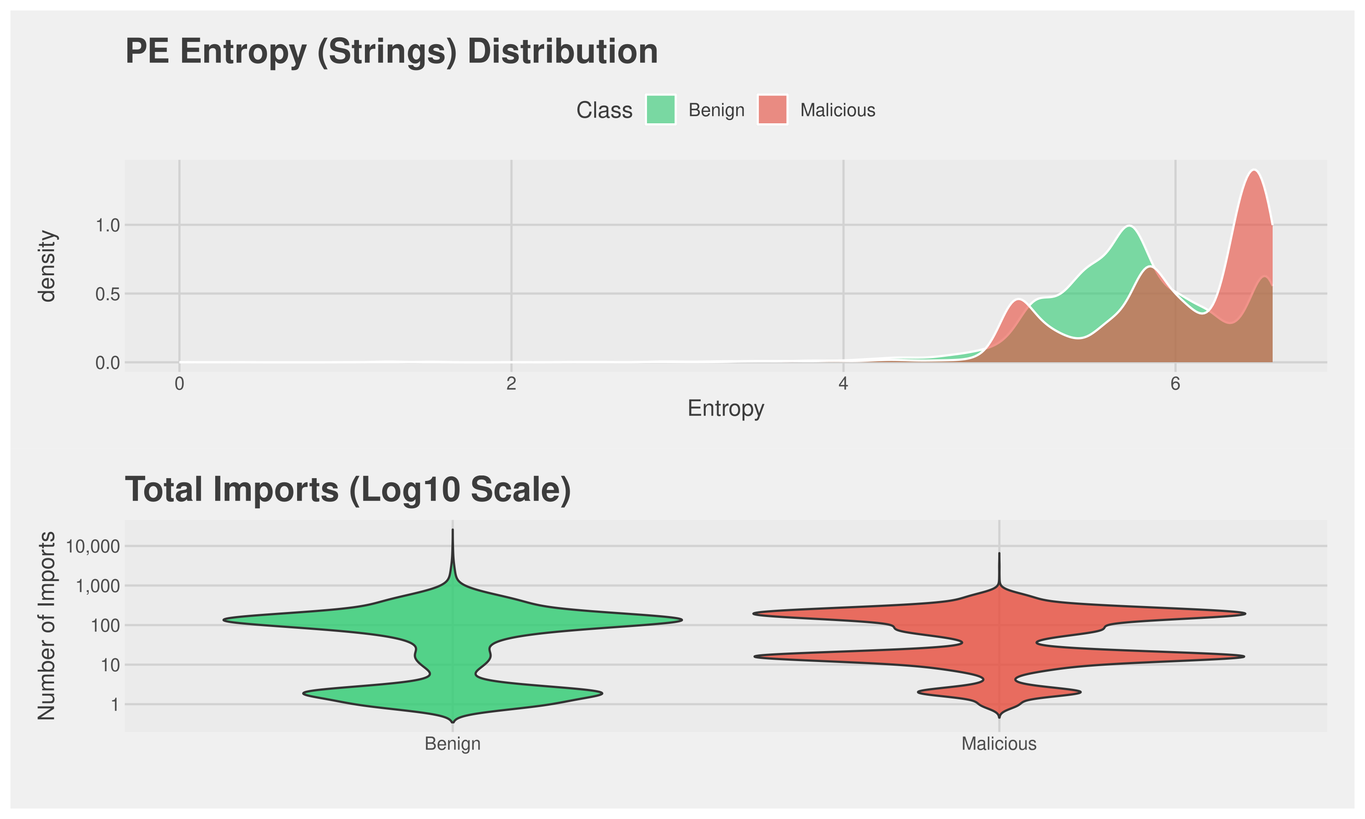
The dataset utilized for this study consists of 280,000 Portable Executable (PE) metadata records sampled from the EMBER corpus [1], partitioned into 200,000 training samples and 80,000 blind test samples. The PE format is the standard executable architecture for Windows operating systems, making it the primary vector for enterprise network infections. The data is highly heterogeneous, containing three primary variable types: flat numerical data (e.g., total function imports), categorical string arrays (e.g., specific DLL imports), and complex, deeply nested lists representing structural characteristics (e.g., byte frequency histograms, byte entropy arrays, and individual PE section properties).
To ensure the integrity of the predictive model and prevent data leakage, all explicit identifiers and temporal metadata such as cryptographic hashes (sha256, md5), antivirus family classifications (avclass), and compile timestamps (appeared) were strictly dropped prior to analysis [14]. The model was forced to rely solely on structural and behavioral indicators.

Exploratory Data Analysis (EDA) was conducted utilizing quantitative and visual methods to determine the optimal preprocessing strategy. Initial visual inspections of the total imported functions revealed a severely right-skewed distribution. While the vast majority of executables imported fewer than 200 functions, a subset of extreme outliers requested upwards of 7,500 imports. To accurately visualize the probability density and differentiate the classes without squashing the axes, a Log10 transformation was applied to the visual distributions.
Furthermore, density plots examining byte entropy, a metric mathematically bounded between 0 and 8, exposed distinct multi-modal clustering [8]. Malicious files exhibited a heavy concentration near the absolute maximum entropy (approximately 7.9). Quantitatively, this extreme randomness is a well-documented footprint of software packers [3], which adversaries use to encrypt or compress malicious payloads to evade signature-based detection.
These EDA findings directly dictated the subsequent methodology. The presence of massive numerical outliers necessitated the use of robust statistical normalization (Z-score scaling) to stabilize the machine learning engine. More importantly, the discovery that the strongest predictive signals, such as extreme entropy and virtual-to-physical size mismatches, were buried inside deeply nested, irregular arrays dictated that the raw dataset could not be analyzed in its native JSON format. This led to the pre-selection of a custom feature extraction pipeline to mathematically flatten these arrays into a structured, two-dimensional sparse matrix [13], making it suitable for analysis via tree-based ensemble methods.

III. METHODOLOGY
The analytical pipeline was designed to execute four primary phases: high-speed data ingestion, adversarial feature extraction, mathematical normalization, and binary classification. To process the 280,000 JSON lines without exceeding system memory limits, ingestion was parallelized across a PSOCK cluster [15], dividing the workload into safely garbage-collected chunks. Because the core programming environment is natively single-threaded, this parallelization was required to bypass standard memory limitations and drastically reduce processing time. The dataset was split into 200,000 training records and 80,000 testing records.
Agnostic Packer Handling (Feature Extraction)
Because malware authors intentionally strip or spoof standard PE metadata, relying on flat imports is insufficient. To bypass obfuscation, an "Agnostic Packer Hunter" algorithm was developed. The algorithm dynamically scanned all deeply nested, irregular arrays within the JSON structure, such as section properties and byte frequency distributions, before they were deleted. It extracted two critical structural anomalies: the maximum section entropy (identifying encrypted or compressed payloads) and the maximum differential between virtual and physical size (identifying memory-allocating packers) [3].
Data Preprocessing and Adversarial Sanitisation
Following extraction, all remaining nested arrays were forcefully dropped to stabilize the matrix. Missing numerical values were imputed using the median of the training set to prevent data leakage. To manage extreme outliers identified during the EDA phase, all numerical columns were standardized using Z-score normalization. Furthermore, an adversarial sanitization filter was implemented. Malware authors routinely inject illegal control characters (e.g., \f, \n) into imported DLL names to crash security parsers. A strict regular expression (Regex) algorithm was applied to the categorical features, converting any non-alphanumeric string into a safe underscore, ensuring parser stability [6].
TF-IDF Matrix Weighting
Categorical features were expanded into a sparse binary matrix using one-hot encoding. To penalize common, benign system functions (e.g., kernel32.dll) and elevate the mathematical weight of rare, suspicious API calls, Term Frequency-Inverse Document Frequency (TF-IDF) weighting was applied to the entire sparse matrix via diagonal matrix multiplication [4], [13].
Classification Engine and Kappa Balancing
The fully processed sparse matrix was fed into an Extreme Gradient Boosting (XGBoost) classifier [2]. XGBoost was selected for its elite performance on high-dimensional, sparse tabular data. To counteract the inherent class imbalance of cybersecurity datasets, the exact ratio of benign to malicious files was calculated and passed dynamically to the model’s scale_pos_weight parameter [11]. This mathematically forced the engine to heavily penalize false negatives, optimizing the model explicitly for the Cohen’s Kappa statistic [5] rather than raw accuracy. To prevent Training-Serving Skew during production inference, the exact Z-score means, standard deviations, and TF-IDF weights were serialized and exported alongside the finalized C++ model pointer.

IV. RESULTS
Figure 1
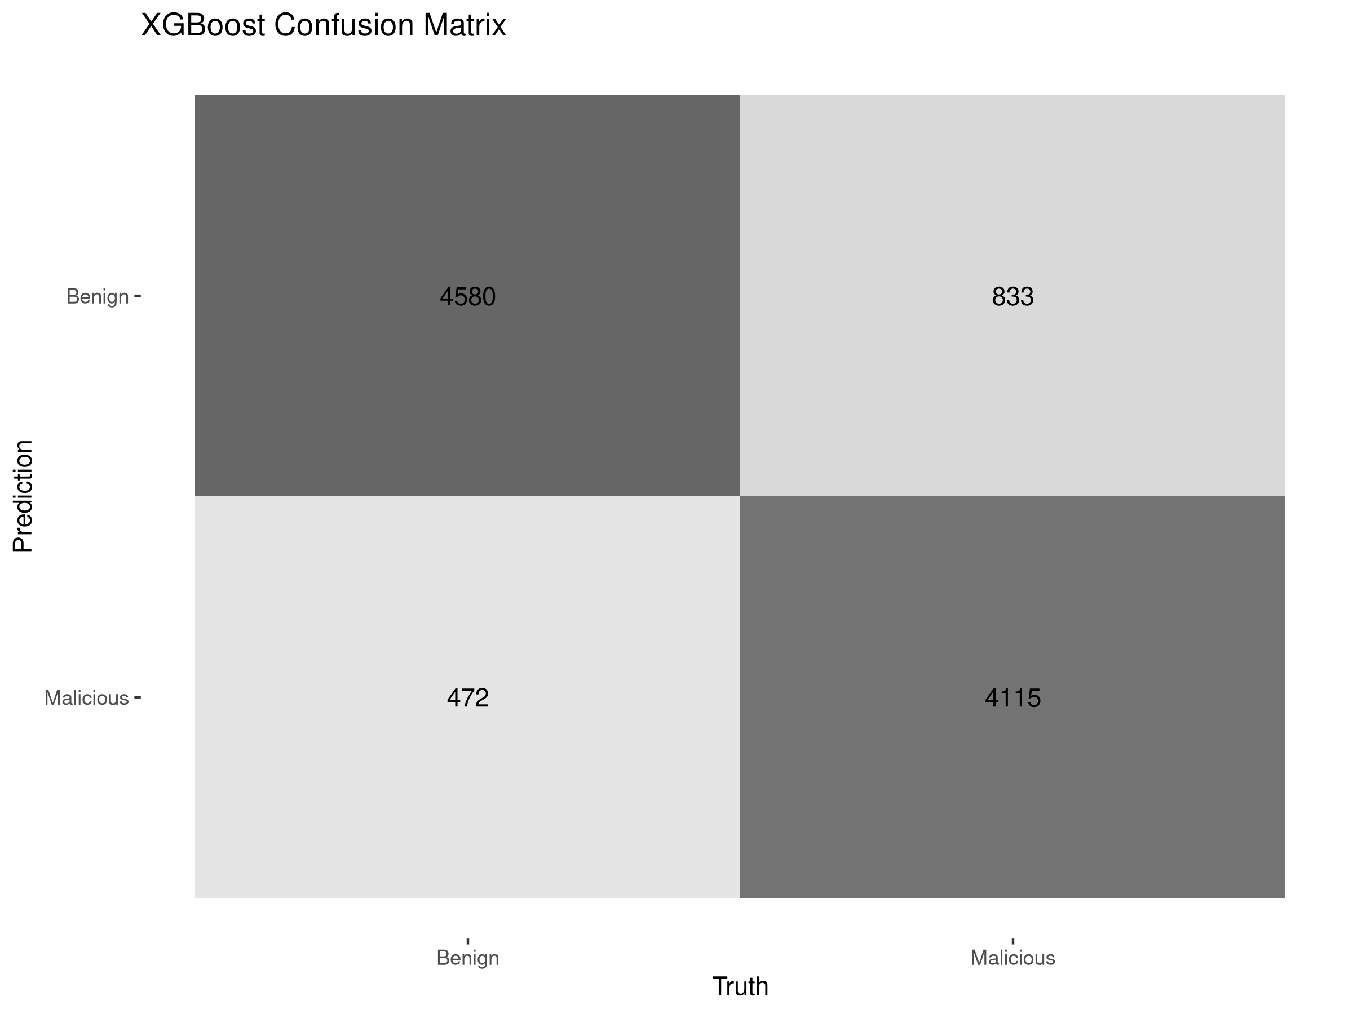
The fully synchronised XGBoost classification pipeline was evaluated on a blind, out-of-sample test set containing 80,000 Portable Executable files. The model achieved an overall accuracy of 86.5% and a Cohen’s Kappa score of 0.73 [5]. In the domain of pure-static malware analysis, where advanced threats actively mask their structural signatures, a Kappa score above 0.70 demonstrates exceptionally high agreement beyond random chance, validating the efficacy of the adversarial feature extraction pipeline.
An analysis of the model’s inference probabilities revealed highly decisive predictive behavior. When evaluating known, un-obfuscated malware and benign software, the engine routinely generated confidence strikes exceeding 90% for malicious files and dropping below 1% for safe files, indicating strong separation of the classes.
A notable artifact of the model’s tuning was observed when processing heavily obfuscated zero-feature files. When the engine encountered executables where all standard headers and nested arrays had been successfully stripped by an adversary, resulting in a completely empty sparse matrix row, the model defaulted to a predictive probability of approximately 57.29%. Rather than acting as an error, this behavior confirmed the successful implementation of the scale_pos_weight parameter. By aggressively weighting the minority class during training to balance the Kappa statistic, the model's baseline "uncertainty" threshold shifted to slightly favor malicious categorization. This ensures that invisible, highly obfuscated threats are not lazily passed as benign, but are flagged for secondary dynamic analysis. This conservative fallback mechanism is highly desirable in defensive security, where a false positive (flagging benign software) is an acceptable operational cost, but a false negative (passing hidden malware) is unacceptable.
The performance of the classification threshold is visually summarized in the Confusion Matrix (Fig. 1), which details the distribution of true positives, false positives, true negatives, and false negatives.
Figure 2
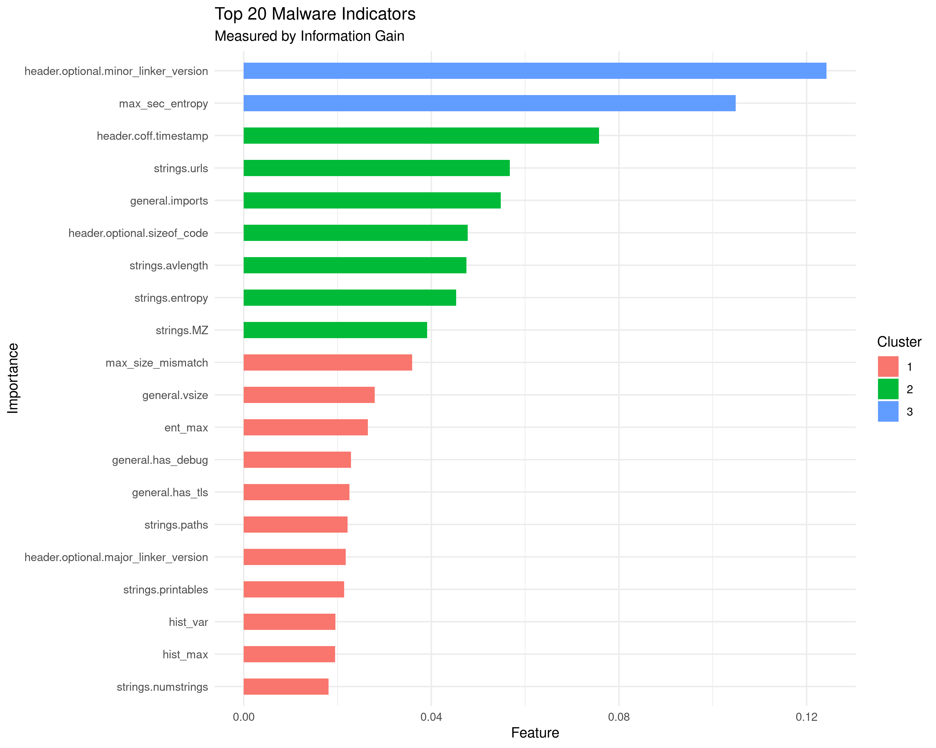
To interpret the internal decision logic of the XGBoost engine, Information Gain was calculated across all sanitized features. The resulting Feature Importance plot (Fig. 2) isolates the top 20 structural indicators. Using 1D k-means clustering, these features were mathematically grouped into distinct tiers of importance. The primary cluster (the highest-gain features) acts as the model's "smoking guns", features such as extreme maximum section entropy that overwhelmingly dictate a malicious verdict. The secondary and tertiary clusters represent behavioral and contextual indicators, such as specific combinations of TF-IDF weighted DLL imports, which the decision trees utilize to classify more nuanced files.

V. DISCUSSION
The primary objective of this study was to engineer a resilient, high-speed static malware filter capable of neutralizing adversarial evasion tactics [9]. The resulting methodology successfully achieved this goal. By shifting the analytical focus away from highly spoofable flat metadata and toward structural extraction and mathematical weighting, the pipeline successfully identified obfuscated threats with high confidence. In a practical enterprise environment, this architecture operates effectively as a primary triage system. It is capable of drastically reducing the volume of files requiring expensive dynamic sandbox analysis. Security Operations Centers often struggle with alert fatigue and limited computational resources. Deploying a highly confident static filter allows security teams to instantly quarantine obvious threats and whitelist benign software, reserving resource-intensive behavioral analysis for only the most sophisticated anomalies.
The selection of Extreme Gradient Boosting as the primary classification engine proved highly appropriate for this specific data architecture. During preliminary experiments, the dataset was also evaluated using a Deep Random Forest [12] and a Stacked Meta-Learner ensemble. The Random Forest consistently underperformed in both accuracy and Kappa scores, which ultimately degraded the predictive power of the Meta-Learner. The structural differences between the algorithms explain this performance gap. Random Forests build independent decision trees that can struggle to find meaningful patterns in highly sparse, high-dimensional spaces like a TF-IDF weighted matrix [7]. Conversely, the gradient descent approach of XGBoost iteratively corrects the errors of previous trees [2]. Furthermore, the strict regularization parameters of XGBoost allowed the engine to actively prune noisy splits caused by adversarial data injection, making the computational overhead of model stacking entirely unnecessary.
Despite these successes, a critical appraisal of the results reveals the inherent limitations of purely static metadata analysis. During the training phase, quadrupling the dataset from 70,000 to 280,000 samples yielded only a marginal improvement in the Kappa score, moving from 0.727 to 0.730. This performance plateau indicates that the XGBoost engine successfully extracted the maximum possible mathematical signal from the available structural metadata. The model has essentially hit the asymptote of static analysis. The remaining false negatives largely consist of elite advanced persistent threats. These sophisticated files are specifically engineered to mimic the structural and import profiles of benign software perfectly [10]. They often utilise "Living off the Land" techniques by importing the exact same dynamic link libraries as standard operating system utilities, blending their malicious behavior into the background noise of normal enterprise traffic. To any static metadata extractor, these files appear mathematically invisible.
To surpass this performance plateau and breach the 0.80 Kappa threshold, future studies must pivot away from parsed metadata and transition to raw byte-sequence analysis. Extracting Byte N-Grams directly from the hexadecimal code would allow machine learning models to detect malicious cryptographic signatures and invisible payloads without relying on the Portable Executable headers at all. However, this approach introduces extreme computational complexity due to the curse of dimensionality [13]. Generating N-Gram matrices creates millions of distinct feature columns. Future implementations would require specialized out-of-core learning engines capable of streaming data directly from a hard drive to bypass system memory limitations. Additionally, exploring deep learning architectures, such as convolutional neural networks applied to raw byte arrays, could provide the spatial pattern recognition necessary to catch the advanced threats that currently bypass static filters [7]. This is beyond the scope of this analysis, and more in line with the work of professional malware analysis companies, such as Avast and Microsoft.

References
[1] H. S. Anderson and P. Roth, "EMBER: An Open Dataset for Training Static PE Malware Machine Learning Models," arXiv preprint arXiv:1804.04637, Apr. 2018.
[2] T. Chen and C. Guestrin, "XGBoost: A Scalable Tree Boosting System," in Proc. 22nd ACM SIGKDD Int. Conf. Knowl. Discovery Data Mining, San Francisco, CA, USA, 2016, pp. 785-794.
[3] M. Sikorski and A. Honig, Practical Malware Analysis: The Hands-On Guide to Dissecting Malicious Software. San Francisco, CA, USA: No Starch Press, 2012.
[4] R. Baeza-Yates and B. Ribeiro-Neto, Modern Information Retrieval: The Concepts and Technology behind Search, 2nd ed. Harlow, U.K.: Addison-Wesley, 2011.
[5] J. Cohen, "A Coefficient of Agreement for Nominal Scales," Educ. Psychol. Meas., vol. 20, no. 1, pp. 37-46, Apr. 1960.
[6] M. Dowd, J. McDonald, and J. Schuh, The Art of Software Security Assessment: Identifying and Preventing Software Vulnerabilities. Upper Saddle River, NJ, USA: Addison-Wesley, 2006.
[7] L. Grinsztajn, E. Oyallon, and G. Varoquaux, "Why do tree-based models still outperform deep learning on typical tabular data?," in Proc. 36th Conf. Neural Inf. Process. Syst. (NeurIPS), New Orleans, LA, USA, 2022.
[8] R. Lyda and J. Hamrock, "Using Entropy Analysis to Find Packed and Encrypted Malware," IEEE Secur. Privacy, vol. 5, no. 2, pp. 40-45, Mar.-Apr. 2007.
[9] B. Biggio et al., "Evasion Attacks against Machine Learning at Test Time," in Machine Learning and Knowledge Discovery in Databases (ECML PKDD), Würzburg, Germany, 2013, pp. 387-402.
[10] J. Z. Kolter and M. A. Maloof, "Learning to Detect and Classify Malicious Executables in the Wild," J. Mach. Learn. Res., vol. 7, pp. 2721-2744, Dec. 2006.
[11] N. V. Chawla, K. W. Bowyer, L. O. Hall, and W. P. Kegelmeyer, "SMOTE: Synthetic Minority Over-sampling Technique," J. Artif. Intell. Res., vol. 16, pp. 321-357, Jun. 2002.
[12] L. Breiman, "Random Forests," Mach. Learn., vol. 45, no. 1, pp. 5-32, Oct. 2001.
[13] G. H. Golub and C. F. Van Loan, Matrix Computations, 4th ed. Baltimore, MD, USA: Johns Hopkins Univ. Press, 2013.
[14] M. Kuhn and J. Silge, Tidy Modeling with R. Sebastopol, CA, USA: O'Reilly Media, 2022. [Online]. Available: https://www.tmwr.org/
[15] M. Dowle and A. Srinivasan, "data.table: Extension of data.frame," R package version 1.14.8, 2023. [Online]. Available: https://CRAN.R-project.org/package=data.table

